ProjectDesignPhase-II

DataFlowDiagram&UserStories

|  |  |
| --- | --- |
| Date | 05 November 2022 |
| TeamID | PNT2022TMID10246 |
| ProjectName | NewsTrackerApplication |
| MaximumMarks | 4Marks |

DataFlowDiagrams:

ADataFlowDiagram(DFD)isatraditionalvisualrepresentationoftheinformationflowswithinasystem.AneatandclearDFDcandepicttherightamount of the system requirement graphically. It shows how data enters and leaves the system, what changes the information, and where data isstored.

DFDLevel0–NewsTrackerApplication

Example:(Simplified)

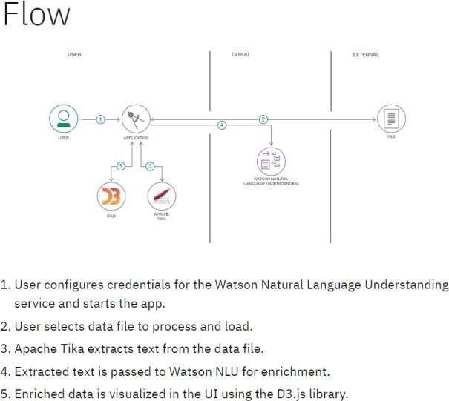

OnlineNewsPortal

LoginManagement

ContentManagement

System userManagement

NewsManagement

ArticlesManagement

News typeManagement

**User Stories**

Usethebelowtemplatetolistalltheuser stories fortheproduct.

|  |  |  |  |  |  |  |
| --- | --- | --- | --- | --- | --- | --- |
| **UserType** | **FunctionalRequirement**  **(Epic)** | **UserStory**  **Number** | **UserStory/Task** | **Acceptancecriteria** | **Priority** | **Release** |
| Customer(Mobileuser) | Registration | USN-1 | Asauser,Icanregisterfortheapplicationbyenteringmyemail,password,andconfirmingmy  password. | Icanaccessmyaccount/dashboard | High | Sprint-1 |
| Customer(Mobileuser) |  | USN-2 | Asauser,IwillreceiveconfirmationemailonceIhaveregisteredfortheapplication | I can receiveconfirmationemail&  clickconfirm | High | Sprint-1 |
|  |  | USN-3 | Asauser,IcanregisterfortheapplicationthroughFacebook | Icanregister&accessthe dashboard withFacebookLogin | Low | Sprint-1 |
|  |  | USN-4 | Asauser,IcanregisterfortheapplicationthroughGmail | I can register & accessthe dashboard with GmailaccountLogin | Medium | Sprint-1 |
|  | Login | USN-5 | As a user, I can log into the application byenteringemail&password | I canlogintotheofficialpage | High | Sprint-1 |
|  | Dashboard | USN-6 | Daytodaynews, feeds,categories, tech newsand  otherupdates | I canseeallthenews  whichIwanted | High | Sprint-1 |
| Customer (Webuser) | Browsing | USN-7 | Enterthewebsiteonthebrowser | I can even login throughbrowser | Medium | Sprint-1 |